**Section 3: Time Series, Aggregation, and Filters**

***Data Extract vs. Live Connection to the Dataset***

Your data is constantly being updated and you wanted to work with a static file when building your visuals (you will later return to the live connection when the visual is ready)

***Working with Time Series***

Months (in blue): Dimension - ignores higher periods such as year, treated as a category like Gender

Months (in green): Measures - create a proper timeline

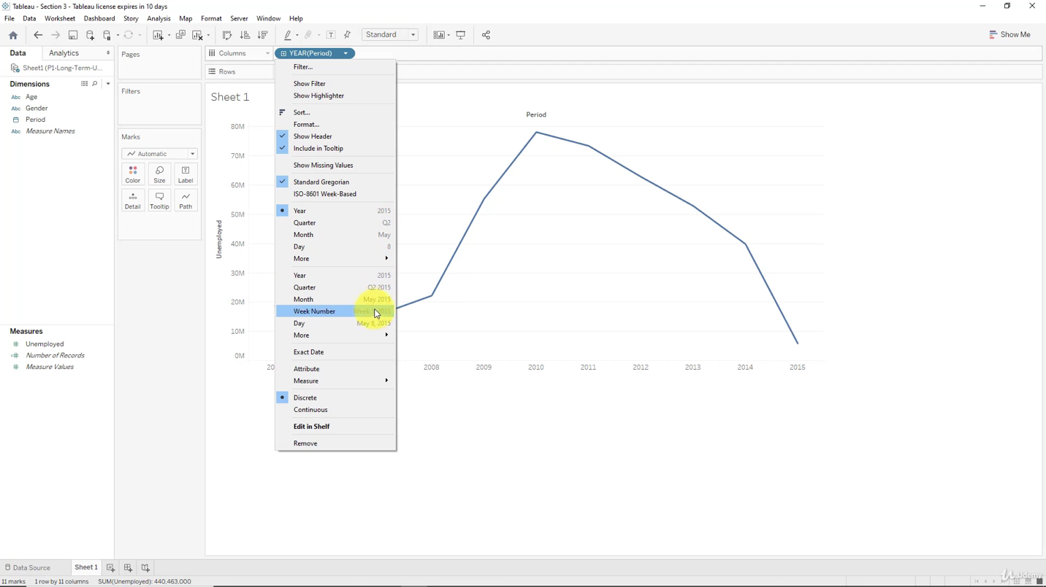

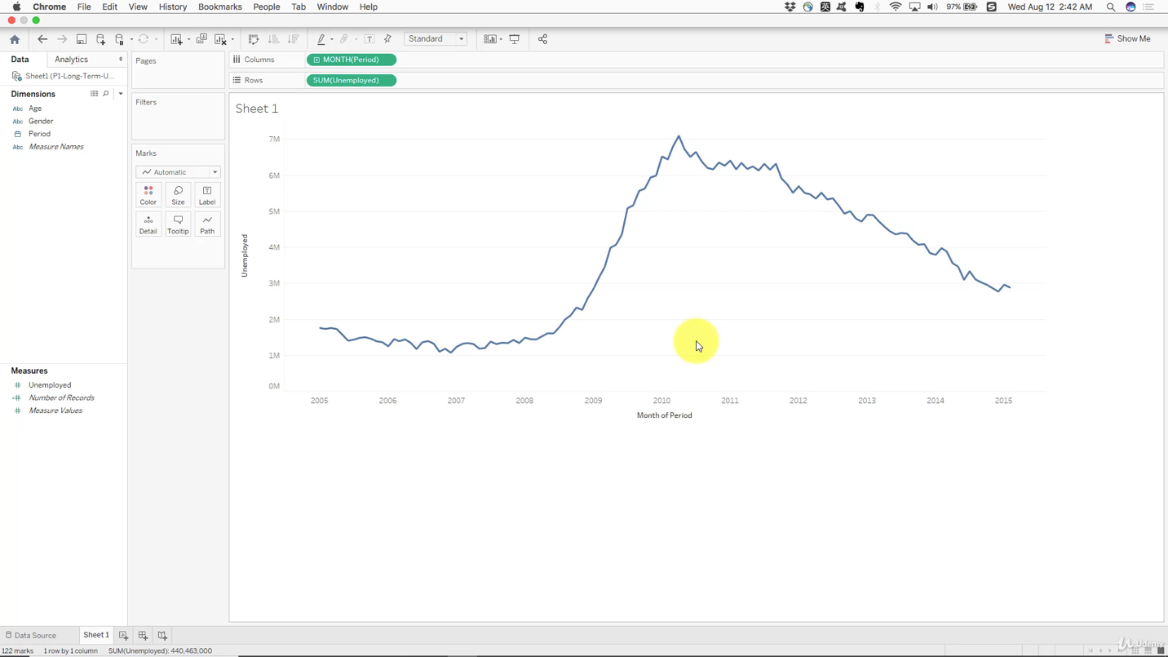

***Aggregation, Granularity, and Level of Detail***

Values are always aggregated at the level of granularity of the worksheet

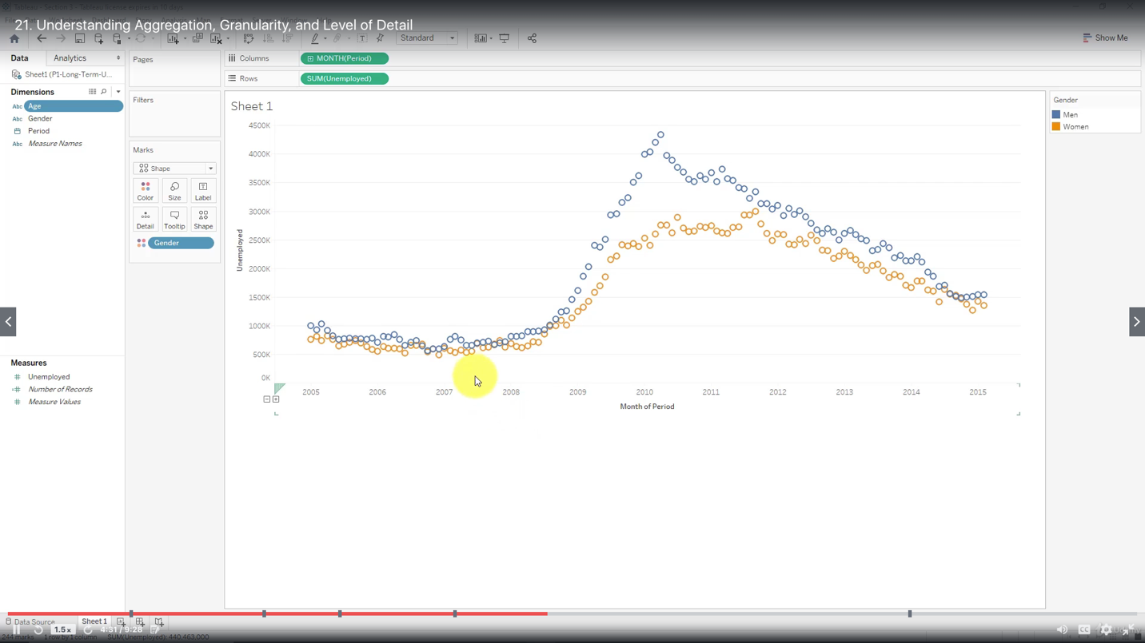

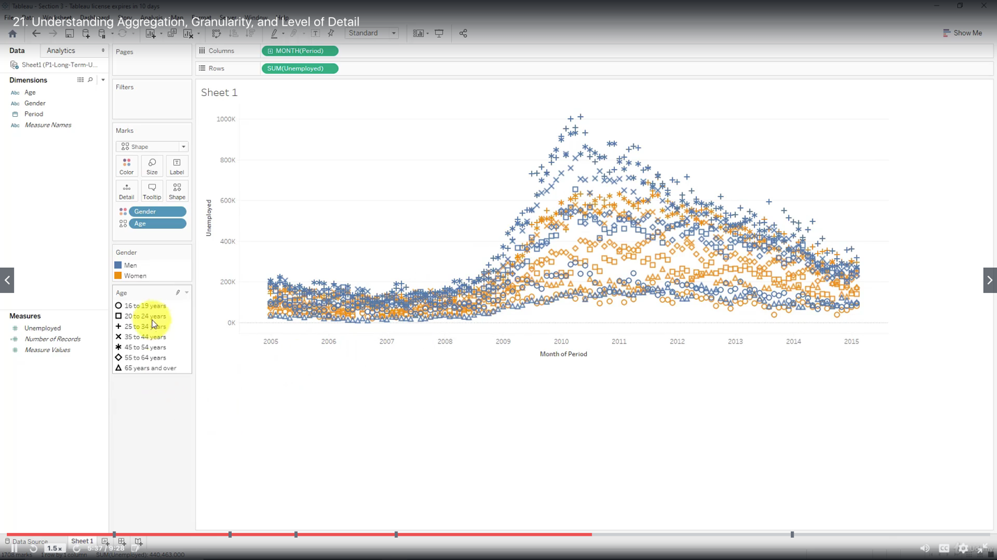

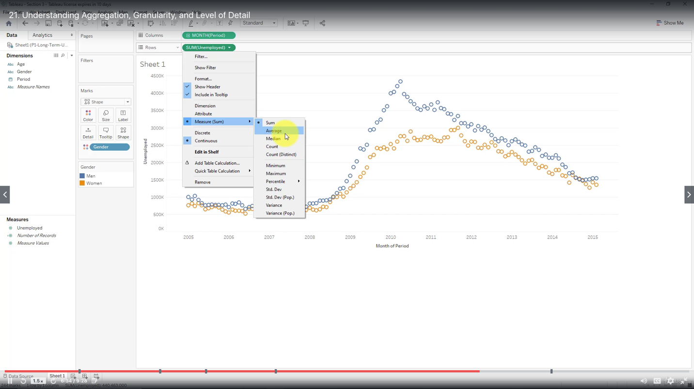

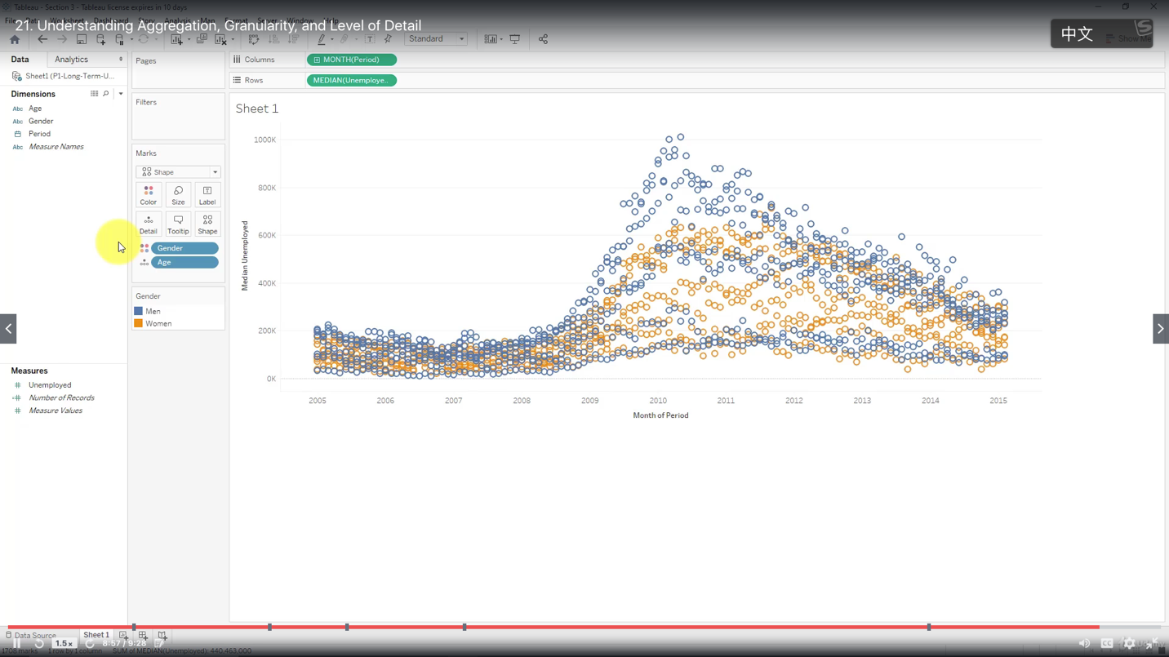

***Highlighting***

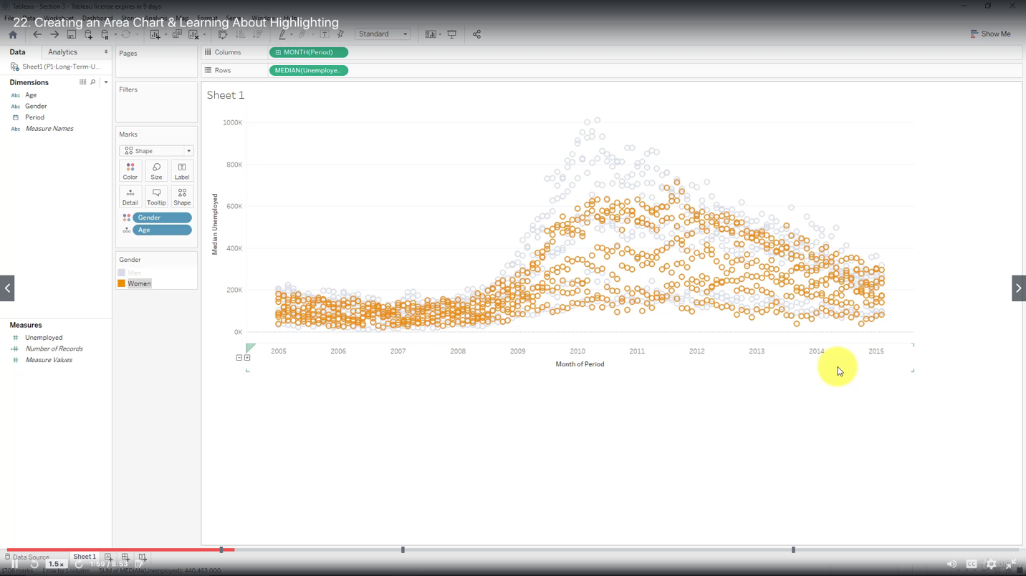

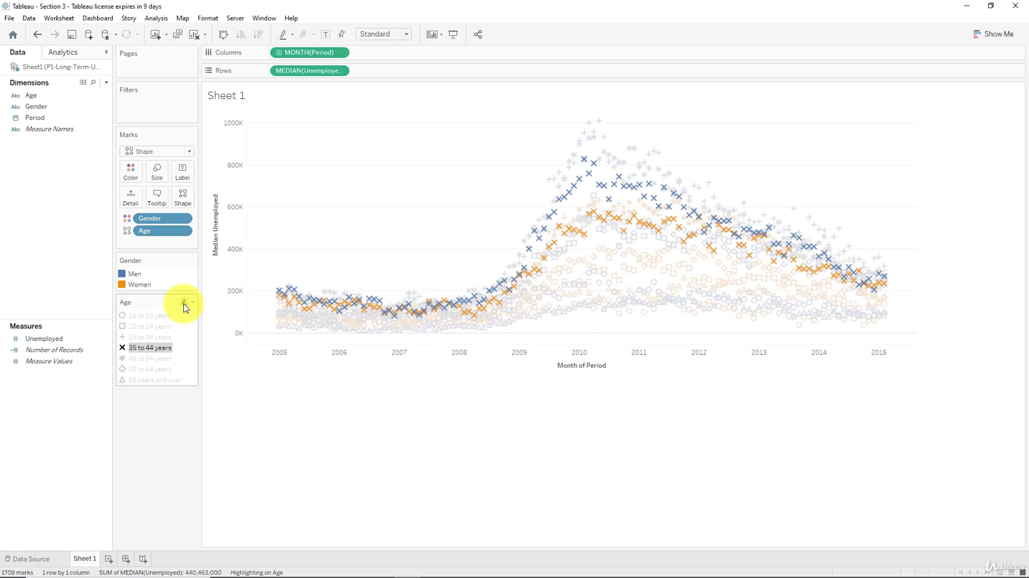

***Area Chart vs Line Chart***

An area chart stacks up values of different categories on top of each other, whereas a line chart visualizes them separately

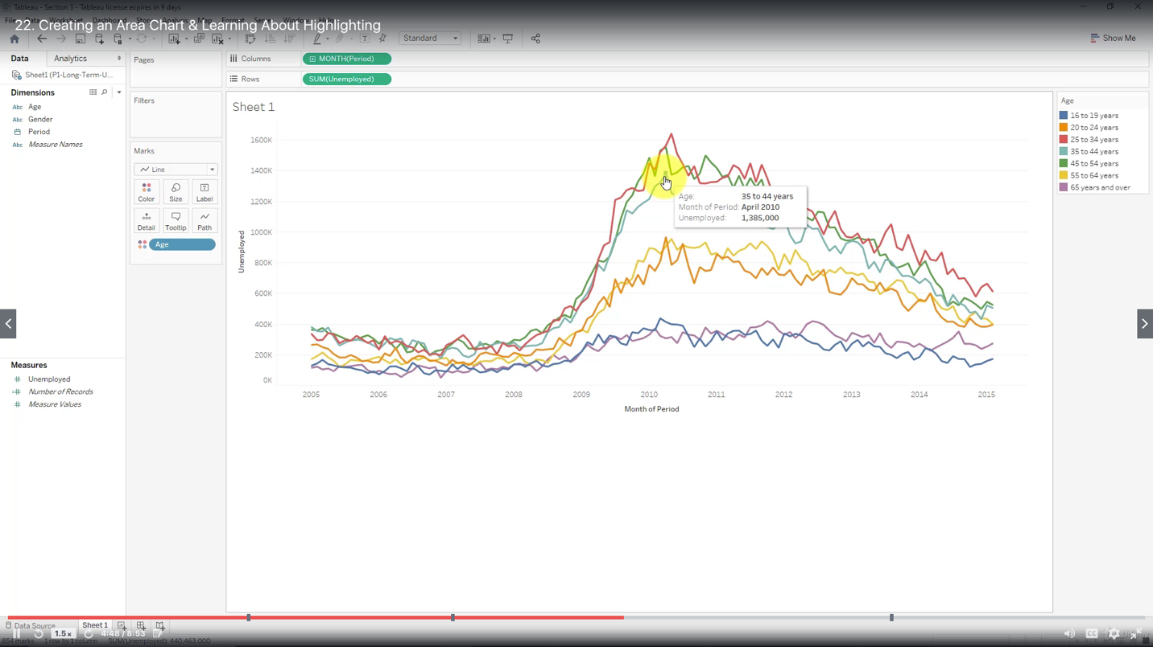

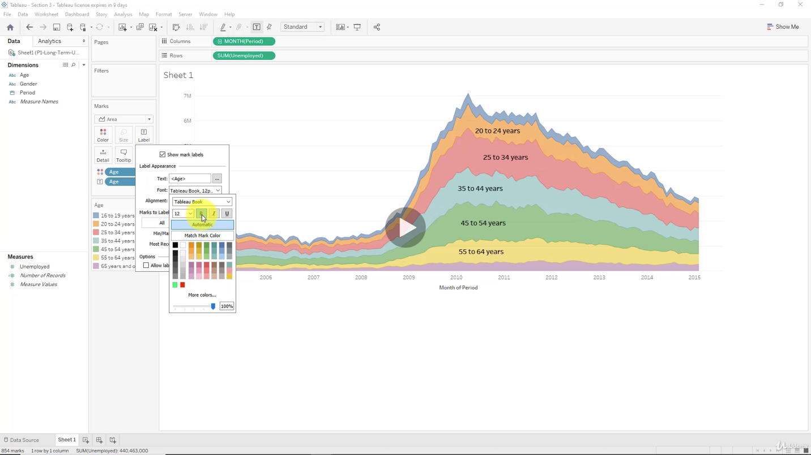

***Filter & Quick Filter***

Type of Quick Filter:

Single Value (List)

Multiple Value (List)

Wildcard Match

